# How should I cite/refer to data in my paper?

A dataset citation includes all of the same components as any other citation:

* author
* title
* year of publication
* publisher (for data, this is often the repository where it is housed, such as [4TU.ResearchData](https://researchdata.4tu.nl/en/))
* version (if indicated)
* access information (a URL or DOI)

APA citation style:

Author/Rightsholder. (Year). *Title of data set* (Version number) [Description of form]. [Retrieved from https://] **OR** [DOI]

[DataCite](http://www.datacite.org.s3-website-eu-west-1.amazonaws.com/cite-your-data.html) citation style:

Creator (PublicationYear). Title. Version. Publisher. ResourceType. Identifier

(Version and ResourceType are optional)

For example:

Heydarian, H. (Hamidreza); Schueder, F. (Florian); Strauss, M.T. (Maximilian); van Werkhoven, B. (Ben); Fazel, M. (Mohamadreza); Lidke, K.A. (Keith); Jungmann, R. (Ralf); Stallinga, S. (Sjoerd); Rieger, B. (Bernd) (2018) Single-Molecule Localization Microscopy (SMLM) 2D TU Delft logos. TU Delft. Dataset.<https://doi.org/10.4121/uuid:0d42a28f-f625-41a3-ba77-25e397685466>

At [4TU.ResearchData](https://researchdata.4tu.nl/en/) you can click on the “**Cite**” button to get a suggested citation and to obtain the DOI of the dataset:

You can also check <http://citeas.org/> to see how you should cite a resource.

You should cite your dataset directly in the paper in places where it is relevant, and include a citation in your reference list, as well as include a **Data availability statement** at the end of the paper (before the acknowledgement section). See below for some examples.

# Examples data availability statements

* The data that support the findings of this study are openly available in [repository name] at [http://doi.org/[doi](http://doi.org/%5Bdoi)].

## If no DOI is issued:

* The data that support the findings of this study are openly available in [repository name] at [URL], reference number [reference number].

## When there is an **embargo** period you can [reserve your DOI](https://surfdrive.surf.nl/files/index.php/s/NmfhUd73BgaQfVW/download) and still include a reference to the dataset in your paper:

* The data that support the findings will be available in [repository name] at [URL / DOI] following a [6 month] embargo from the date of publication to allow for commercialisation of research findings.

## When data cannot be made available:

* Restrictions apply to the data/software that support the findings of this study. [Explain nature of restrictions e.g. the data contains information that could compromise the privacy of research participants, NDA, licensing, agreements] Data are available upon reasonable request by contacting [name and contact details] and with permission of [third party name].
* The data that support the findings of this study are available upon request. Access conditions and procedures can be found at [URL to restricted access repository such as [4TU.ResearchData](https://researchdata.4tu.nl/en/)].

See [here for some more examples of Data Availability Statements](https://www.library.manchester.ac.uk/using-the-library/staff/research/research-data-management/sharing/data-access-statements/).

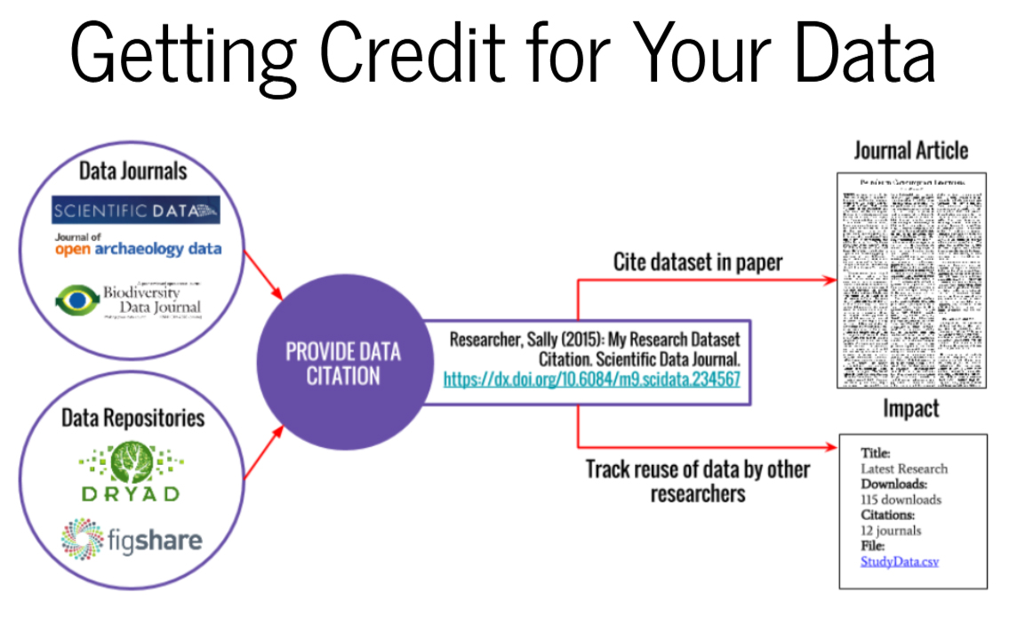

[Slide](https://nyu-dataservices.github.io/Intro-RDM/index.html#/23) by Vicky Steeves.

# Software citation

**There is a tool that helps you create a CITATION.cff for your software:** [**CFFinit**](https://citation-file-format.github.io/cff-initializer-javascript)**.**

The recommended format (Katz et al. 2020; <https://doi.org/10.12688/f1000research.26932.1>) for software citation is to include:

**• Creator(s):** the authors or project that developed the software.

• **Title:** the name of the software.

• **Publication venue:** the publication venue of the software, preferentially, an archive or repository that provides persistent identifiers.

• **Date**: the date the software was published.

• **Identifier:** a resolvable pointer to the software, preferentially, a PID that resolves to a landing page containing descriptive metadata about the software, similar to how a Digital Object Identifier (DOI) for a paper that points to a page about the paper rather than directly to a representation of the paper, such as the PDF.

• **Version**: the identifier for the version of the software being referenced. If the version is unidentified or unknown, the date of access should be used.

• **Type**: some citation styles (e.g., APA), require a bracketed description of the citation (e.g., Computer software) to be included.

If a published article exists that describes the software, it should be cited as an additional reference.

Example (APA):   
Developer, A. A., Developer, B. B., & Developer, C. C. (yyyy) 1. Title of the software: Subtitle (Version #.#) 2. [Computer software] 3. Publisher 4. <https://URL5>

See [Katz et al. 2020](https://doi.org/10.12688/f1000research.26932.1)) for more examples.