Potential Virtual Ship case studies

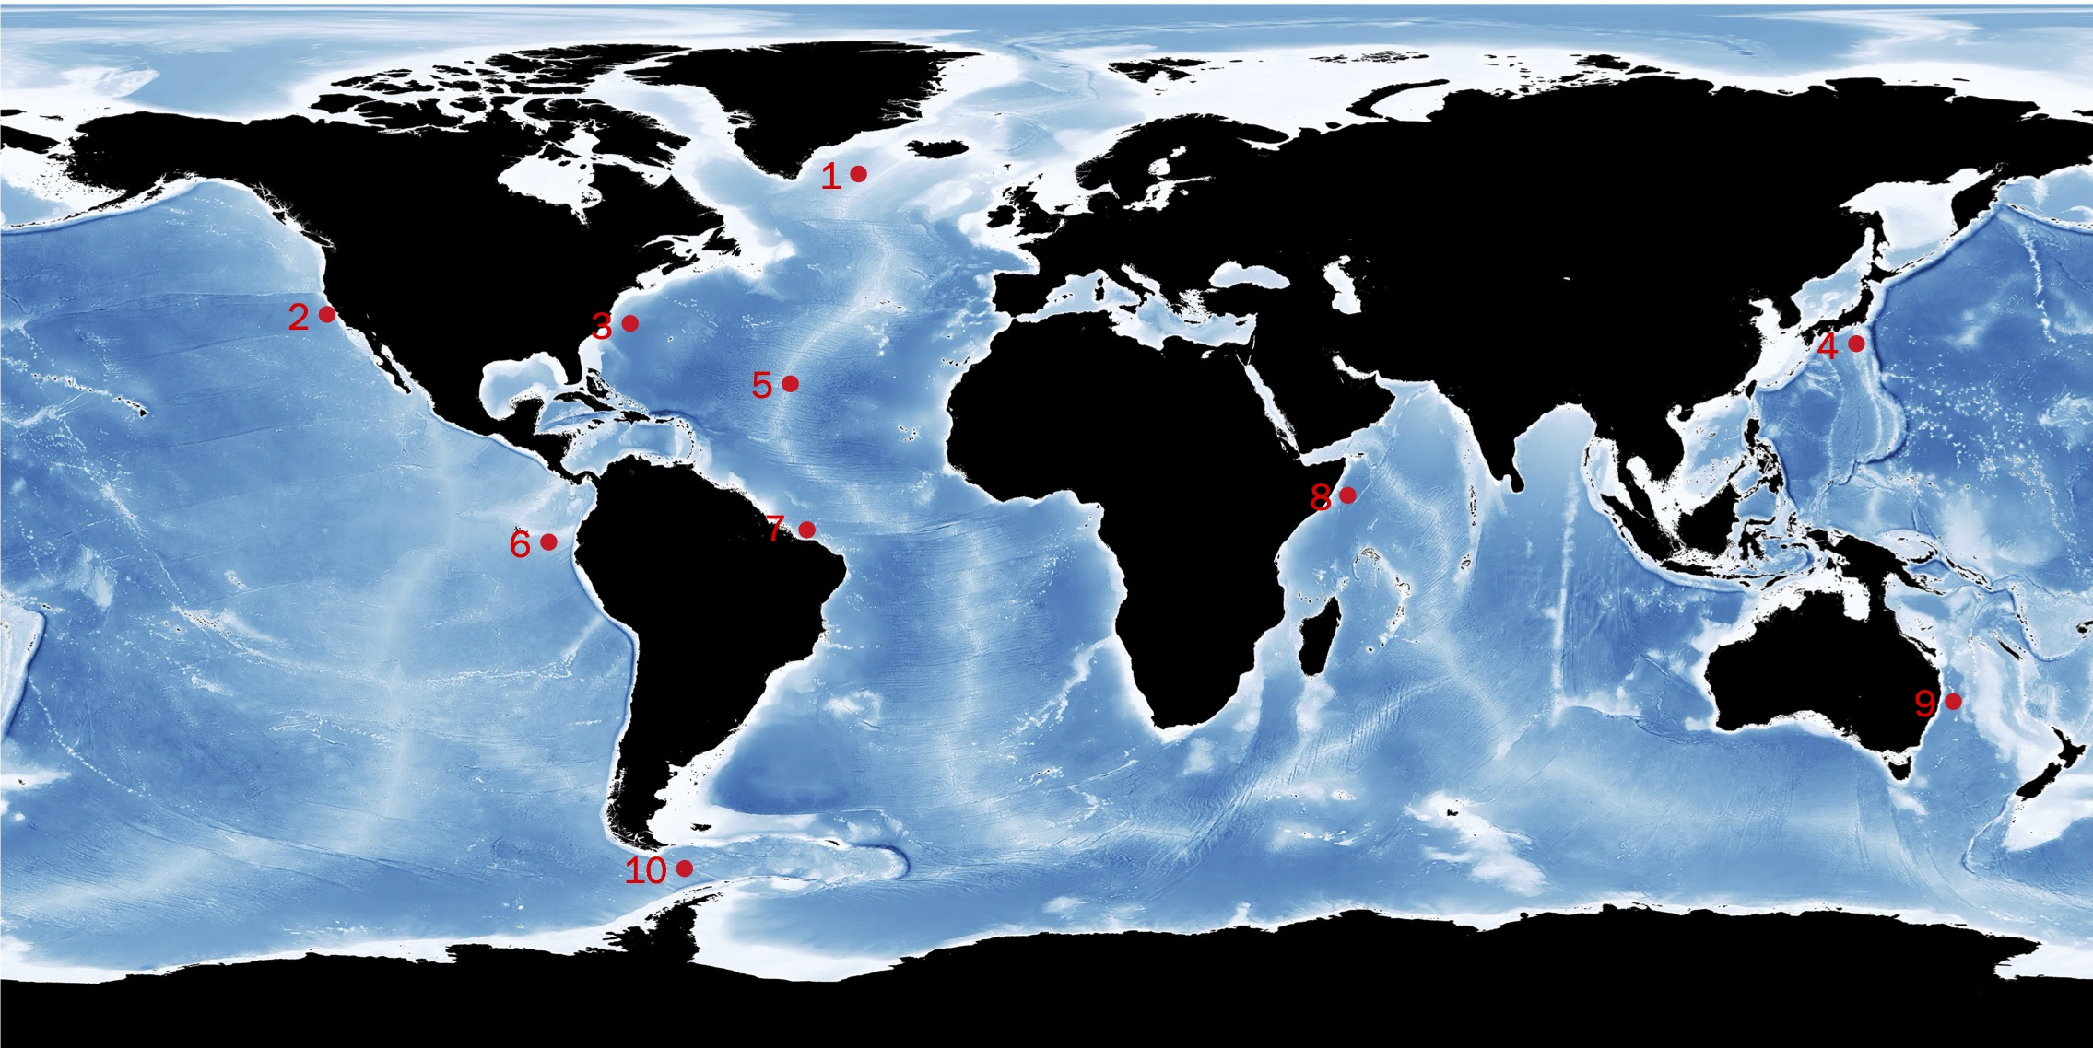

1. **Irminger Sea**

The Irminger Sea is one of the windiest places in the global ocean and one of few places on Earth with deep-water formation that feeds the large-scale thermohaline circulation. The Irminger Sea, situated between southern Greenland and the Reykjanes Ridge, is a critically important area of the North Atlantic. Currents that begin in the Arctic pass through the sea and meet North Atlantic water, forming new kinds of dense water that sinks and flows to the equator.

1. **California current**

The California Current is the eastward portion of the clockwise North Pacific Gyre and transports low salinity, cool water equatorward. Associated with the coastal surface flow is a poleward undercurrent, the California Undercurrent. Also, extensive upwelling of colder sub-surface waters occurs, caused by the prevailing northwesterly winds acting through the Ekman Effect. The winds drive surface water to the right of the wind flow, that is offshore, which draws water up from below to replace it. The upwelling further cools the already cool California Current. This is the mechanism that produces California's characteristic coastal fog and cool ocean waters.

1. **Gulf stream and Deep Western Boundary Current**

In the North Atlantic, there are two main western boundary currents related to the Atlantic Meridional Overturning Circulation (AMOC): the Gulf Stream flowing northward and the Deep Western Boundary Current (DWBC) flowing southward. The Gulf Stream influences the climate of the coastal areas of the East Coast of the United States, and to a greater degree, the climate of Northwest Europe. A consensus exists that the climate of Northwest Europe is warmer than other areas of similar latitude at least partially because of the strong North Atlantic Current.

1. **Japan current**

The Kuroshio Current is also known as the Black Current or Japan Current is a north-flowing, warm ocean current on the west side of the North Pacific Ocean basin. It was named for the deep blue appearance of its waters. The Kuroshio Current is one of the largest and strongest ocean currents in the world, flowing 2 to 4 knots on average. It can be considered as the Pacific Ocean’s equivalent of the Atlantic Ocean’s Gulf Stream, in that both currents transport the ocean’s warm, tropical and nutrient rich waters northward, up towards the Polar Regions, with a crucial effect on regional climate and human activities.

1. **Atlantic Meridional Overturning Circulation**

The Atlantic Meridional Overturning Circulation (AMOC) is part of a global thermohaline circulation in the oceans and is the zonally integrated component of surface and deep currents in the Atlantic Ocean. The general thermohaline circulation is a pattern of water flow through the world's oceans. The AMOC consists of upper and lower cells. Observing and understanding the changes in the AMOC is critically important for identifying the mechanisms of decadal climate variability and change, and for interannual-to-decadal climate prediction. Because this is a very broad topic it would be wise to mimic one of the ongoing research programs, e.g. <http://www.oceansites.org/tma/move.html>.

1. **El Niño-Southern Oscillation**

El Niño and La Niña are the warm and cool phases of a recurring climate pattern across the tropical Pacific—the El Niño-Southern Oscillation, or “ENSO” for short. The pattern shifts back and forth irregularly every two to seven years, bringing predictable shifts in ocean surface temperature and disrupting the wind and rainfall patterns across the tropics. These changes have a cascade of global side effects.

1. **North Brazil current**

The North Brazil Current (NBC) is a western boundary current that flows off the coast of northeast Brazil and retroflects between 4°N and 10°N. It is predominantly a salt water current, but it does help transport fresh water from the Amazon River northward. The average salinity of the current occurs at about 5°S, where the more saline South Equatorial Current merges with the NBC. The rainfall produced at the ITCZ works to dilute the salt content of the water. The depth of the NBC is dependent on the depth of the thermocline, as well as the depth of the continental shelf.

1. **Somali current**

The Somali Current is a warm ocean boundary current that runs along the coast of Somalia and Oman in the Western Indian Ocean. This current is heavily influenced by the monsoons and is the only major upwelling system that occurs on a western boundary of an ocean. During the months of June to September, the warm Southwest monsoon moves the coastal waters northeastward, creating coastal upwelling. The upwelled water is carried offshore by Ekman transport and merges with water that was brought to the surface by open-ocean upwelling. Not only does the biological productivity of the region depend on these upwelling currents, they also play a large part in regulating the heat flux budget of the North Indian Ocean.

1. **East Australian Current**

The East Australian Current (EAC) sweeps warm water down the east coast of Australia. Like the Gulf Stream, the East Australia Current is pushed to the western edge of the ocean by the rotation of the Earth. The current carries nutrient-poor water from the Coral Sea into the cool waters of the Tasman Sea. The EAC is the largest ocean current close to Australia, moving as much as 30 million cubic meters of water per second in a broad ribbon that covers as much as 100 kilometers in width and 500 meters in depth. The current is strongest in the early months of the year—the Southern Hemisphere’s summer— and weakens during the winter, the middle of the year.

1. **Drake passage**

The presence of the Drake Passageway allows the three main ocean basins (Atlantic, Pacific and Indian) to be connected via the Antarctic Circumpolar current (ACC), the strongest oceanic current. This flow is the only large-scale exchange occurring between the global oceans, and the Drake passage is the narrowest passage on its flow around Antarctica. Several studies have linked the current shape of the Drake Passage to the Atlantic meridional overturning circulation (AMOC) as we know it.