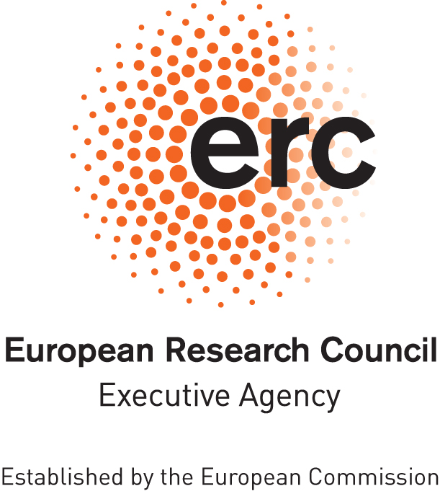

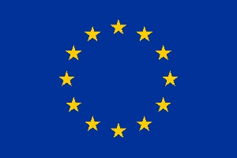

European Research Council (ERC)

ERC Data Management Plan
Template

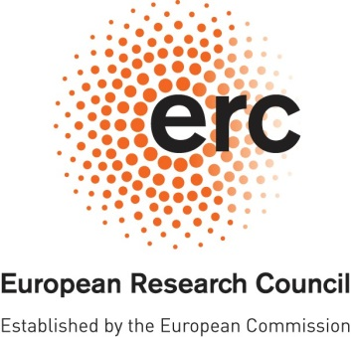
ERC OPEN RESEARCH
DATA MANAGEMENT PLAN (DMP)

Project Acronym | Project Number

Template for the ERC Open Research Data Management Plan (DMP). The following sections should describe how you plan to make the project data Findable, Accessible, Interoperable and Reusable (FAIR). Each of the following five issues should be addressed with a level of detail appropriate to the project.

SUMMARY (dataset reference and name; origin and expected size of the data generated/collected; data types and formats)

During the course of the research project, all data will be stored on local servers (project drive, SURFdrive) maintained and automatically backed up by TU Delft ICT.

1. MAKING DATA FINDABLE (dataset description: metadata, persistent and unique identifiers e.g., DOI)

All data resulting from the project will be made openly available through the 4TU.ResearchData. 4TU.ResearchData is a trusted and certified research data repository (it has a Data Seal of Approval certification). All datasets will be accompanied by rich metadata (adhering to DataCite metadata standard) to ensure that all datasets are findable. In addition, to further aid their discoverability, keywords describing the datasets will be added. 4TU.ResearchData is also using schema.org metadata, meaning that all datasets are indexed in Google Dataset Search. Every dataset will be also assigned a Digital Object Identifier (DOI), to make them citable and persistently available.

All data files will be named using the following elements in the file name:
- Date: YYYYMMDD
- Descriptive file name
- Initials of the person who last modified the file

2. MAKING DATA OPENLY ACCESSIBLE (which data will be made openly available and if some datasets remain closed, the reasons for not giving access; where the data and associated metadata, documentation and code are deposited (repository?); how the data can be accessed (are relevant software tools/methods provided?)

All data/software created in this project will be made openly available through 4TU.ResearchData. All datasets will be made available under a CC-BY license, which requires attribution/credit for the original creation. All software will be made available under an MIT license, following the Five Recommendations for FAIR Software. Each dataset or code repository will have a Digital Object Identifier (DOI) to make them citable and persistently available.

3. MAKING DATA INTEROPERABLE (which standard or field-specific data and metadata vocabularies and methods will be used)

There are no agreed disciplinary standards and vocabularies in our discipline. In order to facilitate data interoperability to the highest possible extent despite the lack of disciplinary standards, we will:
- Create a dictionary of all terms used in our datasets. This dictionary will be publicly shared together with all the datasets at the end of the project.
- Metadata will be collected using lab books.
- All datasets and metadata will be published using 4TU.ResearchData, which uses Dublin Core Metadata Initiative (DCMI) as the standard for metadata. Dublin Core is used worldwide. As a result, it is easy to link metadata to other files and automatically search through them, which increases the interoperability of the data.
- All documentation included in the datasets is provided as a README file in plain text format (.txt)

4. INCREASE DATA RE-USE (what data will remain re-usable and for how long, is embargo foreseen; how the data is licensed; data quality assurance procedures)

All datasets will be licensed under a CC-BY licence which requires attribution/credit for the original creation, while at the same time ensures broadest possible re-use. Datasets will be made publicly available at the time of the publication of corresponding research papers resulting from this study.
4TU.ResearchData ensures data quality and curation (manual curation at the time of deposition, and automated curation and checks for data integrity after the deposit). Research data will be available for at least 15 years from the time of data deposition.

5. ALLOCATION OF RESOURCES and DATA SECURITY (estimated costs for making the project data open access and potential value of long-term data preservation; procedures for data backup and recovery; transfer of sensitive data and secure storage in repositories for long term preservation and curation)

All data will be stored on local servers (project drive, SURFdrive) maintained and automatically backed up by TU Delft ICT, which can be contacted for support with retrieving backups if needed.

4TU.ResearchData is able to archive 1TB of data per researcher per year free of charge for all TU Delft researchers. We do not expect to exceed this and therefore there are no additional costs of long term preservation.

DISCLAIMER. Please note that the ERC Data Management Plan is not a part of the Ethics Review. It is the responsibility of the Principal Investigator to inform the ERCEA Ethics Team of any ethics issues/concerns regarding the collection, processing, sharing and storage of data in relation to the project.

Several datasets may be included into a single DMP.

