FAIRification Plan Documentation

Phases 1 and 2

1a. Project Initial Goals:

These are objectives from the project in which the FAIRification project is inserted. You should describe the goals that will impact or be impacted by the resulting FAIRified resource(s).

1b. Group of Collaborators

Domain stakeholders are those related to the resource’s domain (clinicians, patient representatives, accountant). A FAIRification project stakeholder is a person or organisation directly involved in the FAIRification project, this can include semantic modellers, a FAIRification project manager, etc. FAIR experts are experts on resources that enable a principle (e.g., an expert in a specific standard or technology like RDF, SPARQL, etc)). The specific stakeholders will depend on your project requirements, research questions and objectives. This list might be revisited several times during planning.
Type of Stakeholder | Stakeholder | Stakeholder Description
Domain Experts
FAIRification Experts

1c, 2a. List of resources to be made FAIR:

List of resources that will be made FAIR. This can include data, ontologies, software, etc. This list also describes if the resources pose any constraints (if any) that may affect the FAIRification project. For example, is the current dataset stored on an online server or just on a USB stick in a researcher's bedroom drawer? Are the headers of an csv file clear enough?
Resource | Resource Description | Limitation

1d, 2b. List of available FAIR supporting infrastructure and its possible limitations:
An example of supporting infrastructure could be a storage server, firewall, access control system, etc. The description should include what is required of that item and possible limitations. For example, the data storage software does not support SPARQL query in its current version and needs to be updated to do so.
Infrastructure Item | Infrastructure Item Description | Limitation

1e. Project Requirements:
Project requirements are general requirements from the overall project specification (e.g., grant proposal) that impact the FAIRification process (e.g., a specific standard must be used) or are impacted by the resulting FAIRified resource (e.g., the resource is easy to find by the related community).
Type of Requirement | Description

Phase 4

4a. FAIRification Domain Description
A description of the domain should be created and presented here. It will serve as a reference for all stakeholders involved in the FAIRification project. This description should be presented in a way that best suits the needs of the team. A paper abstract format is recommended, but users can also use slides, wiki, tables, etc.

4b. Semantic Types Identified from Current Data:
A list of semantic types (key concepts related to the domain) should be listed here. These terms will initially come from the domain description and are likely to be updated/extended at later stages of this planning. This list should also include a definition of each semantic type and the sources of these definitions.
Semantic Type or Attribute | Definition | Description Source

4f. Reuse stakeholders
These include user groups that will eventually reuse the FAIR resource. These may include the domain stakeholders mentioned earlier in this plan.
Stakeholder role | Stakeholder role’s main goal(s)
Validation Status: this list must be validated by domain experts.

Phase 5

5a, 5b. Competency Questions and Related Stakeholders:

This list contains competence questions that are asked or could be asked by related collaborators (FAIRification project collaborators, domain stakeholders, reuse stakeholders). These should be questions that can only be answered (or answered in a significant easier way) by making the resource FAIR. These questions must consider and connect the semantic types listed above.
ID | Question | Related Stakeholder(s)
CQ1
CQ2

5c. List of goals emerged from competency questions:

This lists goals that emerge from the competency questions listed above. These goals emerge from asking why a CQ exist and how it can be answered.
CQ(s) ID | Goal

5d. Goals aligned to FAIR principles: Figure 2.

At this point, the initial goals identified earlier should be further refined and preferably presented in a goal diagram for easier communication. This refinement can also be done by breaking down the initial goals into more specific ones until they are specified as tasks (operational goals). For this task, it is recommended that you use goal-modelling tools, such as PiStar (edu.nl/4qvnt).

5e-1. Similar FAIRification projects with candidate solutions:

List of similar FAIRification projects where solutions can be reused in the current project. These solutions may include conceptual semantic models, algorithms, etc. It is recommended that you list solutions per the associated FAIR principle.
FAIRification Project | FAIRification Project Description | Candidate Solutions

5e-2. Possible solutions for identified principles:

List of solutions that satisfy a goal in the context of a particular FAIR principle. For example, using PURL or W3ID could be solutions that satisfy F1 in the context of a goal to "keep track of a dog's history across shelters". The table presented on the next page provides a summary of the FAIR principles.
Goal ID | Principle | Possible Solution

Phase 6

6d. FAIRification Decisions Chosen solutions:

List chosen solutions and the reasoning on why this specific solution was prioritised over other alternatives.
Principle | Chosen Solution | Choice reasoning
F1 – Unique ID
F2 – Rich Metadata
F3 – Linking (meta)data
F4 – Metadata is searchable
A1.1 – Open communication protocol
A1.2 – Authentication and authorisation
A2 – Metadata longevity
I1 – Knowledge representation
I2 – FAIR Vocabularies
I3 – Qualified references
R1.1 – Licence
R1.2 - Provenance
R1.3 – Community standards

6e. Required Metadata per Task and Solution Chosen:

Different metadata fields are collected for specific tasks or for the implementation of the chosen solutions. These need to be listed in this table.
Task | Metadata Fields

6g. Required Expertise per Solution:

Certain tasks or specific solutions may require specialised expertise. If so, they need to be listed in this table. Note that hiring some expertise may not be feasible given the project requirements (e.g., budget).
Task | Metadata Fields

Figures (examples)

Figure 1 - Goals per stakeholder. Goal diagrams can be created using the piStar tool. An example is shown below.
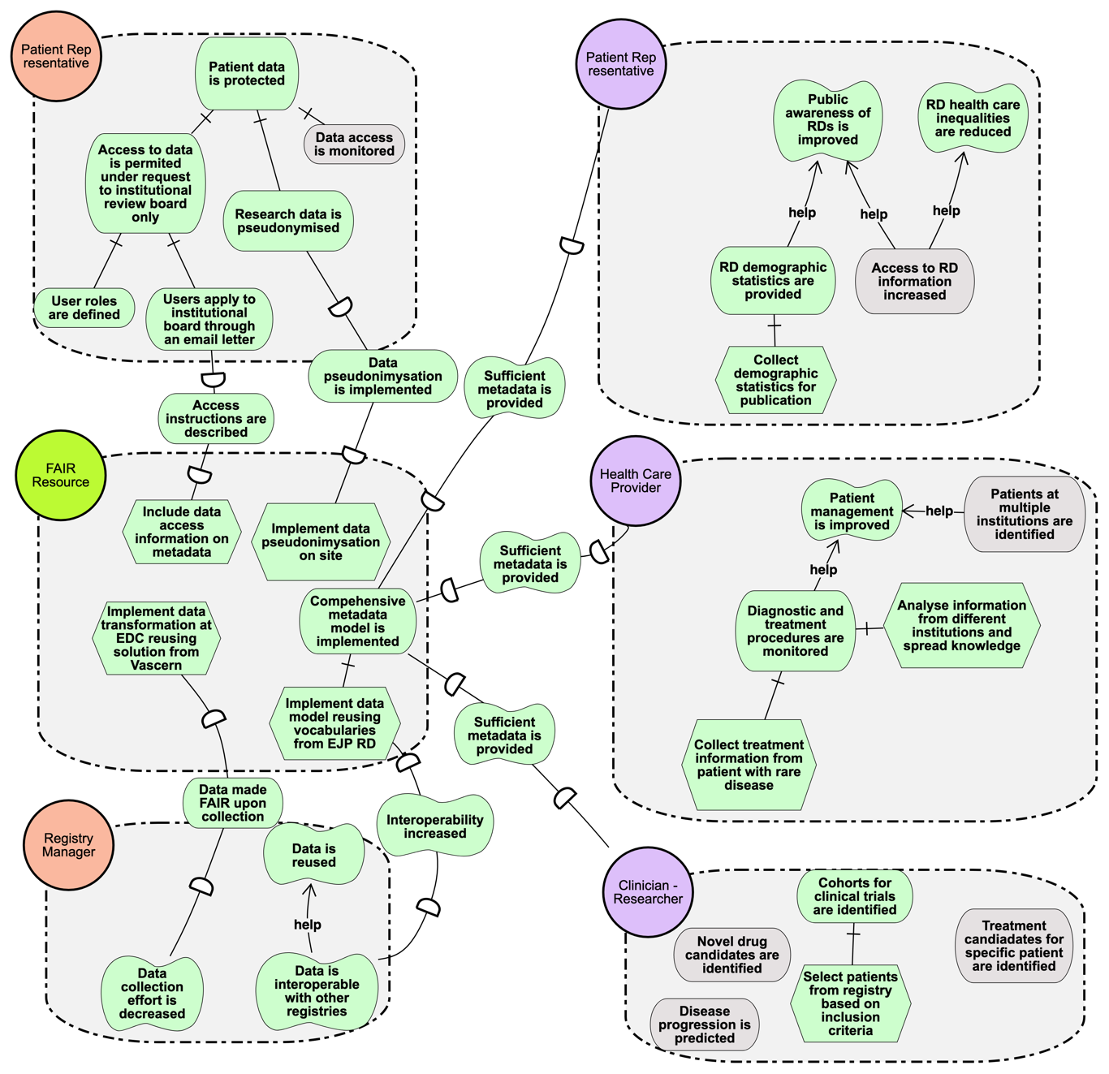

Figure 2 - Complete goal diagram with alignment to FAIR principles. Tasks can be broken down into different perspectives (F, A, I, R perspectives) and then aligned to each specific subprinciple, as in the example below.

